1. Read the question and the student’s answer carefully.
2. Use the mark scheme to award the student a number of marks and annotate their answer with suggestions to improve.
Stretch: Rewrite the answer to show how it should be done!

Question:
Magnesium chloride can be electrolysed. This can take place when magnesium chloride is molten or when it is dissolved in solution.
- Explain why magnesium chloride must be molten or dissolved in solution to be electrolysed. (2)

- Explain how magnesium is produced at the negative electrode when molten magnesium chloride is electrolysed. (3)

Student answer:

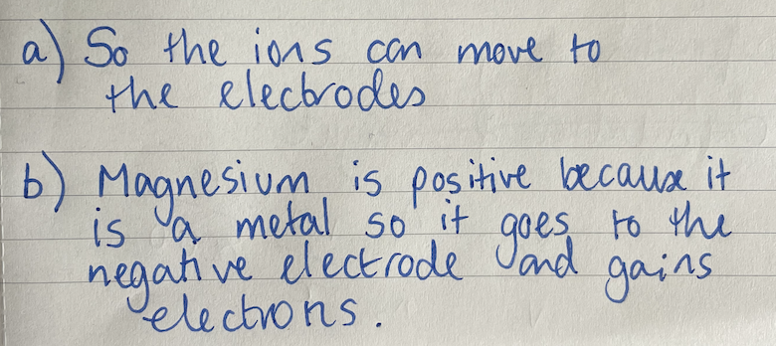

Marks awarded= _________

Mark scheme:
a)
Answer | Mark
Ions (need to be) free to move (to electrodes) | 1
(in order to) carry charge | 1

b)
Answer | Mark
Magnesium ions (Mg2⁺)are attracted to the negative electrode/cathode | 1
(where) they gain electrons/are reduced | 1
2 electrons gained  For marking points 2 and 3 allow:  Mg²⁺ + 2e⁻ Mg | 1

